1.

INCLUDE Irvine32.inc

.data

A DWORD 5

B DWORD 6

valC DWORD 8

RESULT DWORD 0

.code

main PROC

mov eax, A

add eax, B

mov ebx, valC

shl ebx, 1

sub eax, ebx

mov RESULT, eax

call DumpRegs

call writeint

main ENDP

END main

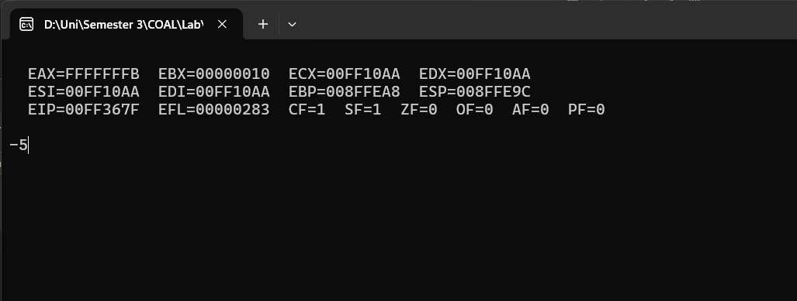

2.

INCLUDE Irvine32.inc

.data

base equ 10

msg BYTE "The area is " ,0

.code

main PROC

height = 15

mov eax, base

imul eax,height

mov edx, 0

mov ebx,2

div ebx

mov edx, offset msg

call WriteString

call writeint

exit

main ENDP

END main

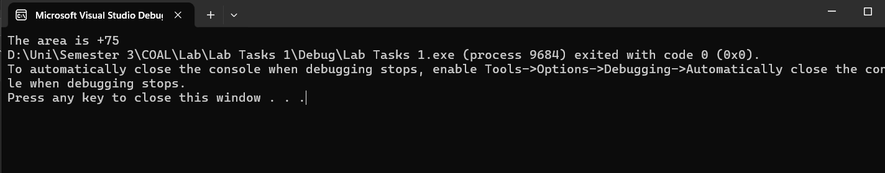

3.

INCLUDE irvine32.inc

.data

baseSalary EQU 150000

daySalary EQU (baseSalary / 30)

overtimePay EQU 4400

leaves DWORD 3

overtime DWORD 2

netSalary DWORD ?

msg BYTE "NET SALARY IS: ", 0

.code

main PROC

mov eax, leaves

imul eax, daySalary

mov ebx, baseSalary

sub ebx, eax

mov eax, overtime

imul eax, overtimePay

add ebx, eax

mov netSalary, ebx

mov eax, netSalary

mov edx, offset msg

call writestring

call WriteInt

call Crlf

exit

main ENDP

END main

